Press release

Modern interior design trend: Large-format tiles
Prague, 23 May 2017 – In the past, large-format tiles were used mainly to cover large spaces, such as commercial buildings or big bathrooms. A newer trend is to use this type of flooring even in smaller bathrooms, where, if chosen with care, they can optically enlarge the room. In addition to bathrooms, large-format tiles have found a home in the living room, kitchen and even bedroom. They look great both on the floor and on the walls. The biggest hit of all are ones imitating natural materials, especially wood and stone.
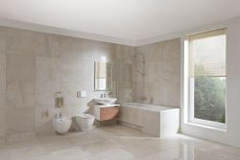
Large-format tiles have a major impact on the overall look of an interior space. Therefore, in choosing a tile we should always think about their placement and the appearance of the selected tiles. “When choosing large-format floor and wall tiles, we should be aware of how colour and also material affects the entire interior. Aiming for a unified interior design makes decision-making much easier; linking the tile on the ground to the one on the walls is a sure bet. For example, the exclusive Di Pietro series from the JIKA brand, which imitates quartzite, is suitable for bathrooms but also excels in the kitchen”, says Radka Konečná, tiling product manager for the JIKA brand. One great benefit of large-format tiles is minimal joints, which is especially important in bathrooms, where moisture can cause mould damage.
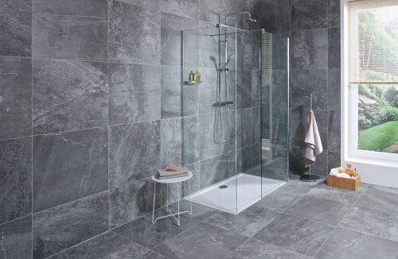
Tiles on the floor and the wall
The unified use of large-format tiles on both the floor and the walls has proven a success even in smaller rooms, which they visually expand. If your bathroom does not quite reach large dimensions, you can choose for the floor and walls a large-format tile in a light tone, such as the beige tiles from the Di Pietro series; owners of larger bathrooms or bathrooms with windows will fall in love with the large-format Di Pietro tile in the shade Marengo.
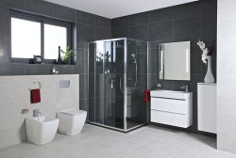
We love concrete
Fans of modern design are sure to appreciate large-format tiles with the look of concrete. The preconception that such a surface looks cold and impersonal is long passé. On the contrary, it is a great blend of purity and elegance. You’ll find such an option in the City series, which has a wide range of formats and surfaces. Tiles can also be combined, and an interesting look can be achieved by choosing one format and tone for the floor and another one for the wall.

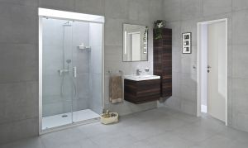
Because tiles imitating concrete are in high demand, JIKA has met customers’ wishes with an offering of large-format tiles with imitation concrete screed in the Focus series and Industria series.

A minimalist style and luxurious surface appearance creates a pleasant and unique space. The Focus tiles excel with a soft waxed surface; the graphic look of the Industria tiles is characterized by a play of hues and tiny lines, which create a three-dimensional effect.

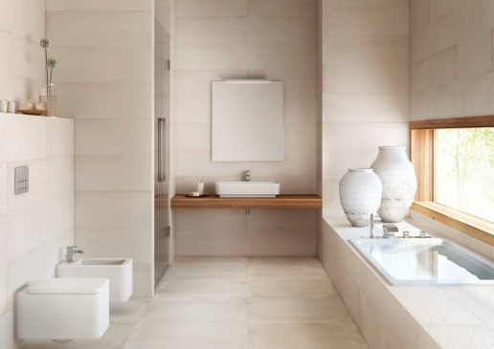
Among tiles with the effect of a concrete surface, the Papyrus series is a singular beauty, with tiles resembling crumpled paper – a true designer delicacy.

Floor tiles with neutral tones allow this effect to really excel in the interior. Papyrus wall tiles can be combined with Industria floor tiles in the same shade, and thanks to the unique surface, you can attain an unconventional, airy space that you’ll never grow tired of.

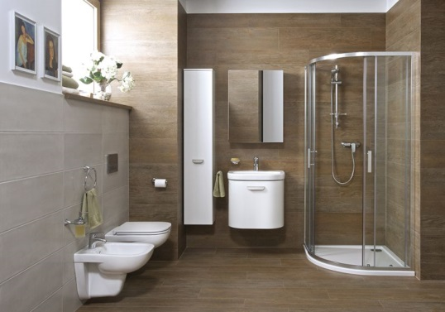
Floor tiles imitating wood are not just for the bathroom
The already mentioned floor tiles with the appearance of natural materials are among the most often requested by customers. If you want to create an oasis of calm in your bathroom, where you will feel as if surrounded by nature, try floor tiles from the Reno series.
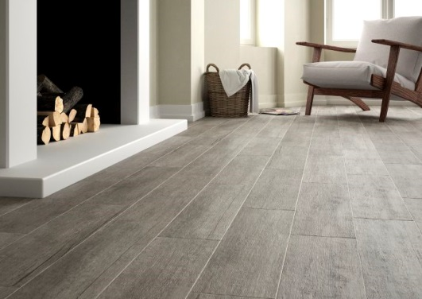
As we have already mentioned, large-format tiles are not only for decorating the bathrooms. They are also well suited for living rooms and kitchens. For those who are afraid that tiles would make their interior seem cold, there’s the Reno or Rustica series with the look of wood. This floor tile is almost indistinguishable from classic wood, but unlike wood it is very easy to maintain, resistant to abrasion and is not harmed by spilled wine or grease.

