JIKA Tigo – new concept for small bathrooms
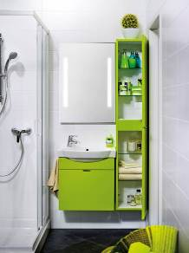
The new bathroom concept JIKA TIGO designed by Michal Janků offers a variety of space-saving solutions where they are needed the most. It includes a set of unified bathroom equipment - washbasins, toilets, furniture and bathtubs.
The shape of Tigo washbasins and asymmetric batteries is adjusted to save each centimetre. The washbasins are also provided with matching cabinets available in four different colours. Tigo furniture offers clear inside arrangement, practical design handles and pull-out frames ensuring maximum space utility.
Light plays an important role in small rooms, especially in the bathroom. CLEAR set of illuminated mirrors makes each bathroom look more spacious and it creates a pleasant atmosphere. The mirrors can be also provided with an anti-fog mirror foil.
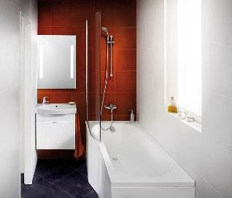
With new JIKA Tigo range you do not have to decide between a bathtub and a shower enclosure. Asymmetric bathtub is specially designed to adapt to the limited space and its wider part provides enough space for comfortable showering. Practical enclosure made of safety glass copies the shape of a bathtub.

